Sector Review of the
Organisation Structure of the
National Bureau of Statistics of Moldova

Report
18 August 2023

Introduction
The Sector Review of the Organisation Structure of the National Bureau of Statistics of the Republic of Moldova (NBS) was undertaken in partnership between a group of international experts convened by the United Nations Economic Commission for Europe (UNECE), and the NBS. The review responded to a request from the NBS in the context of the Strategy for the Development of the National Statistical System of Moldova, 2023-2030.

The Sector Review was conducted by a team consisting of Ms Francesca Kay (Central Statistics Office of Ireland), Ms Mira Nikic (Statistical Office of the Republic of Serbia), Mr Carlo Vaccari (Independent consultant, Italy), Mr Marlen Jigitekov (UNECE), and Mr Steven Vale (UNECE). The review was conducted in cooperation with the managers and staff of the NBS.

The Sector Review findings are based on discussions and presentations during a mission of the review team to the NBS office in Chisinau, which took place on 6-10 February 2023, and was conducted at the same time as a Sector Review of Information Technology in Official Statistics. This report contains the observations and recommendations of the international experts.

The collaboration between the review team and the staff of the NBS was very positive and constructive throughout all phases of the work. The international experts would like to thank the NBS management and staff for this.

Chapter 1: Context: Institutional environment, strategy and resources

The NBS is “an institutionally and professionally independent administrative authority” of the Moldovan government. However, most of its staff (other than interviewers and some information technology staff) are civil servants, so recruitment, salaries and terms and conditions of employment are subject to regulation by the government, and are standard across different government departments, ministries and agencies. This places certain constraints on the management of the NBS, in terms of the scope to reorganise activities and change the official organisation structure.

One practical example of such a constraint is that the pay of managers is partly determined by the number of staff they manage. This means that moving posts from one team to another can have a direct impact on the salaries of the managers of those teams. Given that public sector salaries in Moldova are already considered to be low when compared to equivalent posts in the private sector, any loss of salary could have a strong negative impact on staff members.

Currently the NBS has a rather de-centralised structure, as is typical in the region. There is a head office in Chisinau and 35 regional offices around the country. The NBS has a total of 705 posts plus around 90 contractors collecting data from small farms. 242 posts are located in the head office, and 463 positions/posts in regional offices, including 150 interviewers who collect data from households (LFS and HBS) and 51 supervisors. The primary function of the regional offices is data collection.

In common with many other national statistical offices around the world, the NBS is investing in modernising its data collection activities, including through the greater use of electronic data collection methods as well as increased use of administrative and other data sources, rather than directly collected data. This means that less staff will be needed for data collection activities in the future, however, this will be at least partly offset by an increased need for staff with competencies in the areas of assessing and using non-statistical data sources, data integration, and data analysis. Some reorganisation of roles will therefore become increasingly essential over the coming years.

At the time of writing, the NBS had 113 vacant posts out of the total of 705 (around 15%). This rate seems rather high and is due to various factors including low salaries and restrictions on hiring. However, in some cases, money saved by not paying salaries for vacant posts can be re-used to provide bonuses to staff who take on additional work to cover for the vacancies. This raises the total remuneration of these employees, so could provide an incentive not to fill such vacancies.

The current organisation structure of the NBS is mostly based around traditional subject-matter domains. In the international statistical community, this type of structure is often referred to as a “silo” or “stovepipe” structure. It means that there are many parallel structures carrying out similar processes, but for different statistical domains. Some national statistical offices have moved away from this approach to more process-oriented structures, where similar processes (e.g., collection, processing, analysis and dissemination) are centralised and standardised. Evidence from the national statistical offices that have made this change shows that it delivers efficiency savings, which can be reinvested in new outputs and/or improving quality.

Current Organisational Structure of the NBS

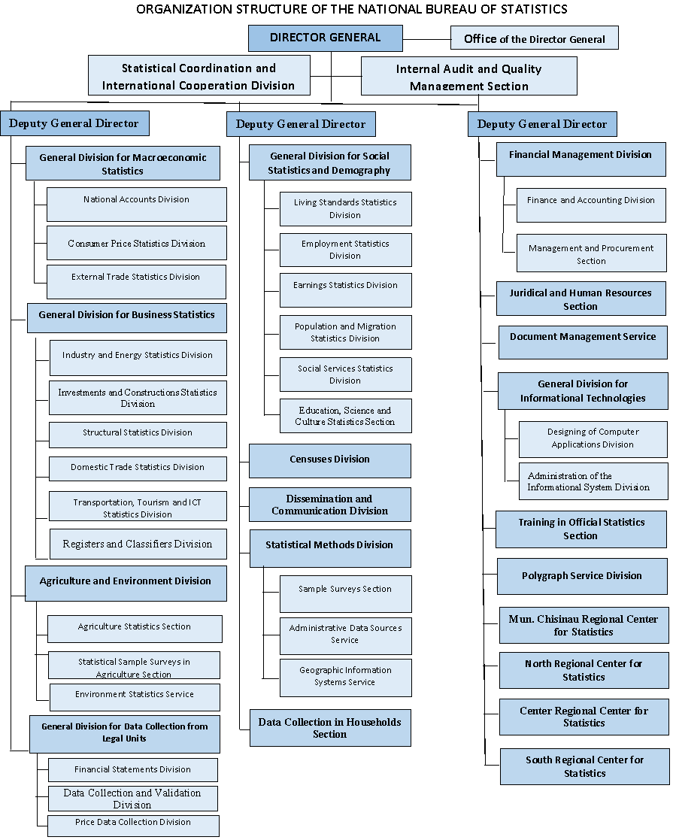
The Strategy for the Development of the National Statistical System, 2023-2030 recognises some of the challenges of the current NBS organisation structure. Within that strategy, Priority Direction 1.4 concerns the “Optimization of the organizational structure of institutions within the National Statistical System” and calls for:
- Regular functional analyses of the NBS structure (every 4-5 years) with reorganisations based on the recommendations of those analyses
- Ensuring the possibility to move posts between NBS structural units, including from the regional offices to the head office and vice-versa
To meet these objectives, it will be necessary to address the constraints outlined above, and to ensure that the NBS management has sufficient freedom to reorganise the structure as needed to improve efficiency. This will become particularly important as Moldova seeks to meet the criteria for membership of the European Union, and particularly the additional reporting requirements contained in the statistics chapter of the accession process.

Chapter 2: Proposals for change

To meet the twin challenges of modernising official statistics and the European Union accession process, it is clear that the NBS structure will need to evolve. This should not be seen as a “one-off” change, but a continuous evolution to reflect changes in user needs, data sources, technologies and statistical methods. The review team recognise that current constraints, including those mentioned in the previous chapter, mean that it is very difficult to make significant changes to the NBS organisation structure in the short term, but would nevertheless like to offer the following recommendations:

1) NBS should leverage the opportunities and challenges of the EU accession process to try to negotiate greater freedom to manage its own organisation structure and the pay of its staff, within the overall financial and staff number envelopes set by the government.

2) The Ministry of Finance, State Chancellery and NBS should discuss how to increase the number of staff in the headquarters to provide NBS with the capacity to facilitate the modernisation process and improve harmonisation with the European Union “acquis Communautaire”. This includes giving the NBS the right to move staff between the regional offices and the headquarters, as recommended in the Eurostat / EFTA / UNECE report on the Global Assessment of the National Statistical System of Moldova, 2019 (Recommendation 5).

3) The Ministry of Finance, State Chancellery and NBS should discuss how to increase the level of salaries of NBS staff, up to the level of ministries and other public institutions, due to the complexity of statistical work, the mixture of capacities needed (data analysis, IT, language skills, elaboration of methodologies, normative acts, adoption of European and global standards. Please see also Recommendation 6 of the Eurostat / EFTA / UNECE report on the Global Assessment of the National Statistical System of Moldova, 2019.

4) NBS should consider matrix management approaches, at least in the short term. This would allow staff to stay in their current places in the organisation chart, but come together to form cross-sectoral teams to work in topics related to statistical modernisation, standardisation and improving efficiency. Given the experiences of remote working from the COVID-19 pandemic, these cross-sectoral teams could also work across physical locations, if suitable staff can be identified or recruited in the regional offices.

5) The government of Moldova should support the NBS to build a well-equipped training centre for:
- Training statisticians from the NBS and the wider National Statistical Service on a regular basis, based on the evaluation of needs and programmes/curricula developed for specific groups: beginners-newcomers/ other statisticians, including providing specific training on the changes needed to fully adopt the European Union “acquis communautaire”
- Training of users to better understand and use official statistics to improve decision making.

6) NBS should further study organisation charts and reorganisation experiences in comparable national statistical offices to see what has worked and what has not worked for others, and consider how the lessons learned could be applied in the case of Moldova. UNECE and other development partners should try to provide opportunities for such exchanges, bilaterally or between groups of countries.

7) NBS should designate one of the Deputy Director General posts as a transformation manager. This person should, in addition to existing management tasks, support the Director General by pro-actively seeking opportunities to modernise the structure, processes and policies of the NBS, with the over-riding aim of improving efficiency.

8) The NBS should continue to seek to fill as many vacant posts as possible, albeit there is a need to weigh the advantages of filling posts against the possible cost to staff who may lose bonuses. The review team feels that if all vacant posts are filled, and the NBS has sufficient freedom to move posts within the organisation as needed, the current total level of posts is reasonable, compared to national statistical offices in other countries. However, in order to make the best use of the available headcount, the NBS needs the authority to recruit and retain the right people with the right skills at an appropriate level of pay.

9) The NBS should see every vacancy as an opportunity to try to recruit the people and skills that the NBS will need in the future. A skills audit to establish current skills, decide those that will be needed in the future, and identify the gaps, will be a useful first step towards implementing this recommendation.

10) Two areas of the NBS that are likely to need strengthening to support the move towards a more process-oriented organisation structure are methodology and IT. This is because these areas are key for setting the institutional standards that are needed to reduce duplication of methods and tools, and hence to improve efficiency.

11) NBS should consider the payment basis for interviewers. The current flat rate approach to pay was thought by some NBS staff to have had a negative impact on response rates. A mixed approach, with a lower flat rate and a bonus for each completed questionnaire that meets quality requirements, is often used in other countries.

12) NBS should consider how to improve the productivity of interviewers, particularly those in rural areas with limited transport options, by investigating increasing the use of cluster sampling beyond the Labour Force and Household Budget Surveys. Experiences from other countries may help to determine the optimum balance between deliberately selecting respondents that are geographically close to improve interviewer efficiency, and the risks to the quality and representativeness of the resulting data.

Timeline

The timeline for implementing some of the above recommendations is heavily dependent on the possibilities for NBS management to negotiate greater flexibility in staff allocation and pay decisions. However, it should be possible to start at least preparatory work in some of these areas in the short term, for example piloting a matrix management approach for a specific project (Recommendation 4) and considering how the efficiency of interviewers might be increased (Recommendations 11 and 12).

The review team notes that other countries are facing similar challenges, with requests for similar reviews coming from Armenia and Georgia. Exchanges of ideas and experiences with the national statistical offices of these countries is strongly encouraged (Recommendation 6), as they are starting from a similar position and have a similar legacy from the times of the Soviet Union.

The review team, and UNECE remain ready to provide further support as needed through the modernisation process, and would like to wish the NBS success on this journey.

Article 7(1) of the Law No. 93 of 26-05-2017 regarding official statistics
See the report on the Eurostat web site at: https://ec.europa.eu/eurostat/documents/52535/9937638/GA+Moldova+2019/31147f4a-8592-16d7-f588-753f0ad6f5f9

